Victor Yuan

November 3, 2016

Lab 10

Introduction:

This lab examines Dataflow modeling and User Defined Primitives. Dataflow modeling is assign a collection of combination logic gates to a single variable with set inputs. This allows faster coding and design processes. The UDP has an output and user determined number of inputs. In a user defined table, every combination of the inputs and its output is defined for reference. This allows the user to manipulate the Verilog however they wish.

Team Member Responsibilities:

Lab Partner: Noah Stettler

For Experiment one I found the SOP to Y, while Noah found the SOP to Z. otherwise the work was divided evenly on the programing side

Materials:

Lab Computer, Verilog, Putty.

Procedure:

Experiment 1:

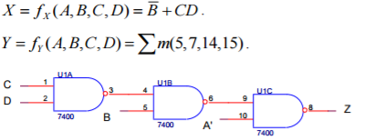

You are giving three values, X,Y,Z. Derive the SOP realization of each, the SOP of x is already given take it as is. Then convert the SOP Realization to Dataflow Model standards using the symbols shown in table 1.

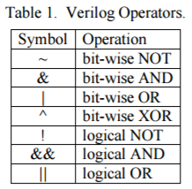

X = B’ + CD would then become X = ~B | C & D, convert Y and Z with the same method. Next input the Dataflow model into Verilog using the keyword “assign”. At this point your inputs should be A,B,C,D and your output should be X,Y,Z display all combinations of A,B,C,D,X,Y,Z. Record data.

Experiment 2:

Take the data gathered from experiment 1 and either put it in a excel document or hand write it. Look at how A, B, C, D and one of the out puts(X, Y, Z). Each output will become a user defined primitive. You are now trying to find combinations of 0, 1 and “?” that will give an output of 0 or 1. You will then put the newly derived table in a method below the Verilog. It should have the following format, however the number of rows the table may have depends on how much you have simplified your table. Make a separate table for output X, Y and Z.

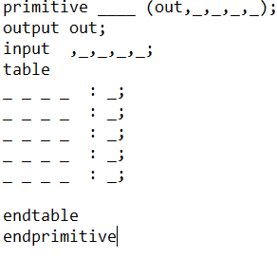

Run the simulation and compare the data with the data you gathered to make the primitive data type (the data from experiment 1). If they match then you have successfully created Your User defined primitive.

Questions:

1. How do your simulation results for the dataflow modeling and UDP modeling compare?

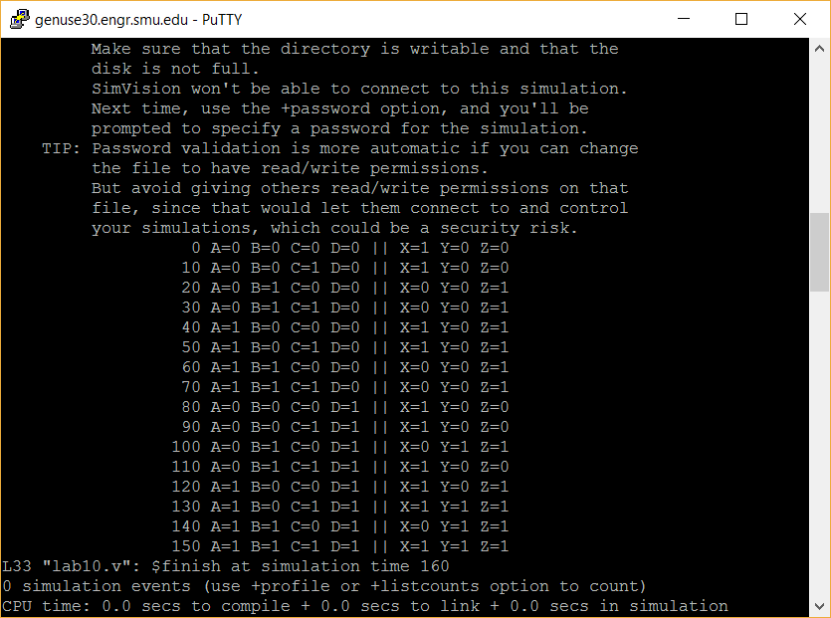

Experiment 1 data

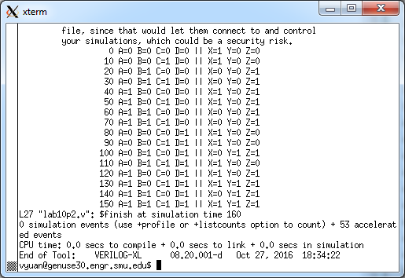

Experiment 2 data They matched, they are exactly the same.

1. How does the amount of your effort involved in dataflow modeling and UDP modeling compare?

Dataflow modeling was a lot faster and easier than UDP Modeling for this lab. However if there were more than just four input variables and we knew every combination and its output UDP modeling could be faster and easier if we copied and pasted every single input and output onto the table. Instead of trying to derive an SOP or POS realization.

Conclusions:

The lab was successful in comparing the methods Dataflow Modeling and User Defined Primitives. Seeing how Dataflow has certain advantages such as simplistic coding with slightly more work in finding the SOP or POS realization. And User Defined Primitives having an advantage of establishing itself without knowledge of any of its gates as long as the input and output are established in the table. They both share the ability to speed up design process with reusability of their code and memory saving capabilities while running the code.